# LAB # 06: Spatial Filtering

**Lab Objective:**

The objective of this lab is to perform spatial filtering on images with different filter size.

**Lab Description:**

**Spatial filtering** is an important step of preprocessing of images. Different types of filters like smoothing filters, sharpening filters and rank filters etc. can be applied to images to achieve the desired result.

**Averaging or smoothing filters** consist of integration and they can be used for blurring or noise reduction. Blurring helps to remove small details from an image before further processing like object extraction can be performed on it.

Applying a smoothing filter (or any filter for that matter) involves convolving the filter of a specific size with the entire image. The mask moves pixel by pixel while convolving with the values of the pixel intensities that it covers as shown here:

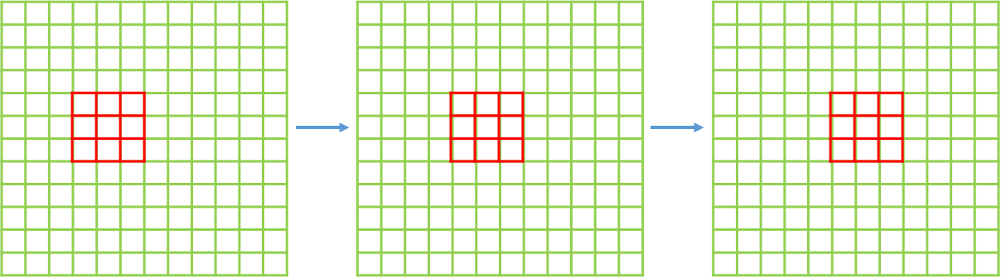

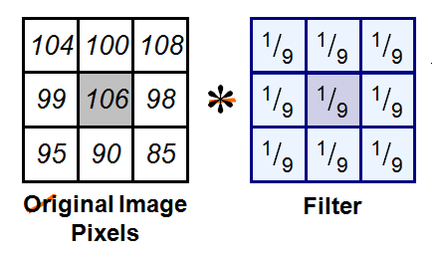 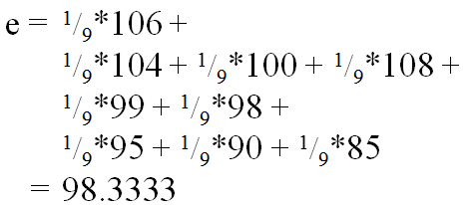

While applying a filter to an image, the boundary of the image impose a unique challenge: for the first pixel of the first row, there are no pixels behind or above it that can be multiplied with the mask value. To counter this problem, two techniques can be used:

* **Padding**

Adding a few rows of 0’s all around the image helps the mask to function properly. The exact number of the 0 rows that are to be added depends on the size of the mask. OR we can replace with neighboring pixel value to avoid affect of zeros on the image

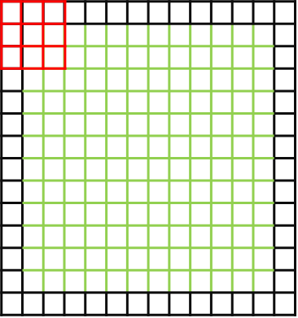

* **Ignoring some rows and columns:**

The first few rows and columns can be ignored and the mask can be applied to the rest of the image. The number of the rows and columns that are to be ignored depends on the size of the filter.

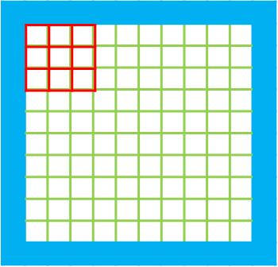

**Lab Task:**

**1:** Write generic functions for each of the following.

* Takes input mask size and their numeric values from the user and create the mask
* Take image and padding size as argument and add padding on the image (either zeros or copy neighboring pixel)
* Take image and filter as argument and apply the filter to the image
* Take image as input and normalize the image between 0 - 255

Now Apply the following Masks the image and display the results

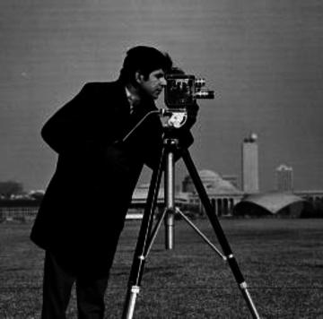a)

|  |  |  |
| --- | --- | --- |
| 1 | 1 | 1 |
| 1 | 1 | 1 |
| 1 | 1 | 1 |

b)

|  |  |  |  |  |
| --- | --- | --- | --- | --- |
| 1 | 1 | 1 | 1 | 1 |
| 1 | 1 | 1 | 1 | 1 |
| 1 | 1 | 1 | 1 | 1 |
| 1 | 1 | 1 | 1 | 1 |
| 1 | 1 | 1 | 1 | 1 |

c) d) e)

|  |  |  |
| --- | --- | --- |
| -1 | 0 | 1 |
| -2 | 0 | 2 |
| -1 | 0 | 1 |

|  |  |  |
| --- | --- | --- |
| -1 | -2 | -1 |
| 0 | 1 | 0 |
| 1 | 2 | 1 |

|  |  |  |
| --- | --- | --- |
| -1 | -2 | -1 |
| 0 | 0 | 0 |
| 1 | 2 | 1 |